**Table of Contents**

**1**.Contact Information  
**2**.Comprehensive list of all of the projects Kelsey was involved in and her contributions

**3**.Stained Slides Inventory

**4-6**. Freezer Inventories

**7**.Deconvolution Project

1. Google Docs
2. ARID1B Experimental Plan
3. FACs Raw Data

**8**. TREG Project

**9**. LC Project

**10**. Spatial DLPFC Project

**11**.Emma’s CeA Experiment

**12**. Xenium Project

**13.** Hb Project

**14**.KCNH2 Project

**15**.Jeremy Day Collaboration

1. Final Figure Illustrator File

**Contact Information**

**Desired name on Publications:** Kelsey D. Montgomery

**ORCiD:** 0000-0001-8420-0138

**Photo for Acknowledgements:**

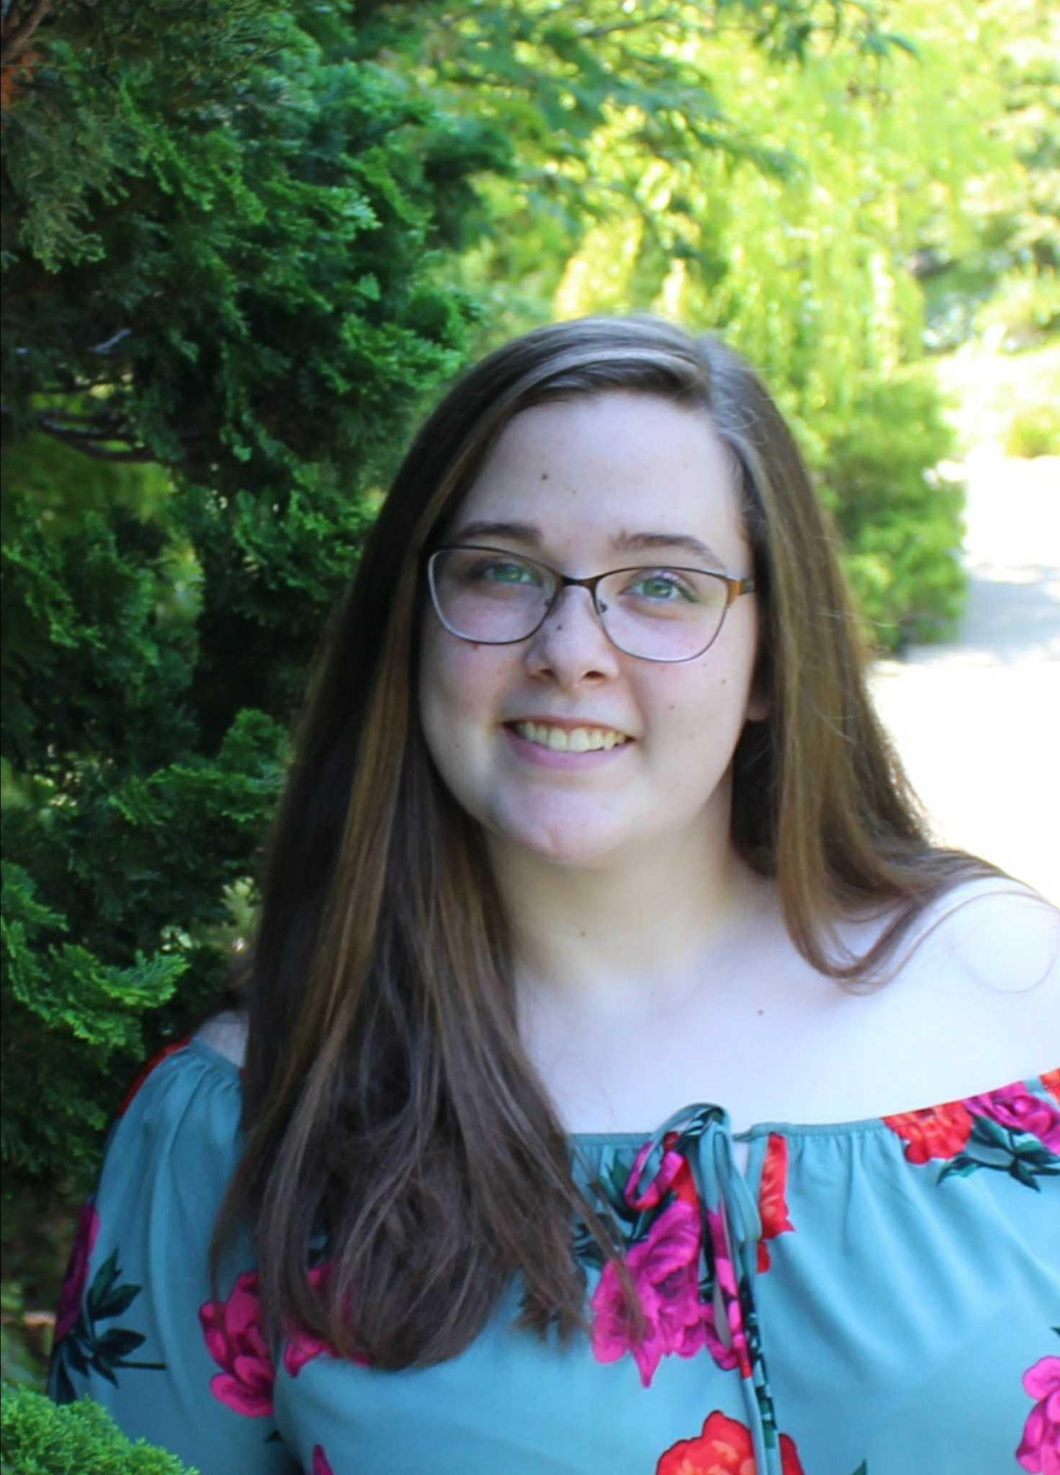

**Projects Involved In**

* **Deconvolution Project**
  + All of the data collection, except nuclei preps
  + Imaging, Unmixing, HALO algorithm building, and preliminary HALO analysis
  + Writing
* **TREG Paper**
  + Data collection: RNAscope & Imaging
  + Writing and figure/table making
* **Spatial DLPFC Project**
  + snRNAseq: sorting and library preps
  + Writing
* **LC Project**
  + snRNAseq: Library preps
  + Writing
* **NAc Project**
  + RNAscope QC
  + Imaging, Unmixing, Fusing in HALO
* **Xenium/Hypothalamus Project**
  + RNAscope QC
  + Imaging & Unmixing
* **Habenula Project**
  + RNAscope original blocks QC
  + snRNAseq: Preps, sort, chromium
  + **Multiome** optimization and 2 successful runs
* **KCNH2 Collaboration**
  + Basescope optimization and finalization
  + CS2 Imaging
* **Jermey Day Collaboration**
  + RNAscope, imagining
  + Figure making
* **TImp Lab collaboration** 
  + snRNAseq from Deconvolution Project
* **RiboZero vs. PolyA** (Possible for Leo)
  + Will use my deconvolution RNA

**Stained Slide Inventory**

|  |  |  |  |  |
| --- | --- | --- | --- | --- |
| **# of Slides** | **Project** | **Location** | **Slide Box Name** | **Assay** |
| 22 | Deconvolution/Invariance | Bay 6, Black fridge, 2nd shelf, left side | IVAR & DECON | RNAscope/IF |
| 10 | NAc | Bay 6, Black fridge, 2nd shelf, left side | NAc Project- Pilot QC RNAScope | RNAscope |
|  | Xenium | Bay 5, End of bay fridge, shelf 3 | Ask Heena | RNAscope |
| 12 | Habenula | Bay 6, Black fridge, 2nd shelf, left side | Hb RNAscope Slides | RNAscope |
| 15 | KCNH2 | Bay 6, Black fridge, 2nd shelf, left side | KCNH2 Project | Basescope & RNAscope |
| 3 | Day Colab | Bay 7, not under bench, top shelf, right side | NAc Abby | RNAscope |

**Freezer Inventory**

**Basement -80 (Freezer 4)**

**3rd Shelf, Rack O**

|  |  |  |  |  |
| --- | --- | --- | --- | --- |
| **Closest to the door** | **Column 1** | **Column 2** | **Column 3** | **Column 4** |
| **Row 1** | Deconvolution Round 1 RNA and unused tissue | Deconvolution Round 5 Slides | NAc 71.02 & 71.03 Slides |  |
| **Row 2** | Deconvolution Round 2-5 RNA | Old Scrap RNA |  |  |
| **Row 3** | Deconvolution Round 3&4 Slides | NAc pilot blocks (71.01-71.04 |  |  |
| **Row 4** | Deconvolution Round 1&2 Slides | NAc 71.01 & 71.04 Slides |  |  |

* Chromium Gel Beads
  + Location: Bottom shelf, no rack, left side
* Multiome Gel Beads
  + Location: Bottom shelf, no rack, right side

**Freezer Inventory**

**Upstairs -80 (Freezer 37)**

**Upper Shelf, Rack 4**

|  |  |  |  |  |
| --- | --- | --- | --- | --- |
| **Closest to the door** | **Column 1** | **Column 2** | **Column 3** | **Column 4** |
| **Row 1** | Heena | Heena |  |  |
| **Row 2** | Heena | Heena |  |  |
| **Row 3** | Heena | Heena |  |  |
| **Row 4** | Heena | Heena |  |  |

* Bioanalyzer RNA NANO Ladder
  + Location: Rack 3, Column 4, Row 4
* Practice Mouse Tissue
  + Location: Rack 3, Column 4, Row 3
* Ovation -80 Reagent
  + Location: Bottom shelf, Rack 4, Column 4, Row 4

**Freezer Inventory**

**Hallway -20**

* Deconvolution cDNA & Libraries
  + Location: Rack B, Column 2, Row 1
* HPC Multiome
  + Location: Rack A, Column 2, Row 2
* HB cDNA & Libraries
  + Location: Rack B, Column 2, Row 1
  + Location: Abby’s cDNA box
* Norgen Kit DNAse Aliquotes
  + Location: Rack B, Column 2, Row 2
* Qiagen Bulk RNA DNAse I Aliquotes
  + Location: Rack B, Column 2, Row 3

**Deconvolution Project**

Google Docs:

* [Deconvolution Plan](https://docs.google.com/document/d/1GXbV134CdPmMcSw9pPeSKeHQ8tBMCf0gLuf5Sq4RF4g/edit)
  + Dissection rounds
  + Blocks used
  + Slide layout
  + snRNAseq and other Decon notes
* [Deconvolution Project RNA](https://docs.google.com/spreadsheets/d/1AbifZvaKnSbrVGh_mVDLXQDpcdhVFVSfVELCx_lvIZs/edit#gid=0)
  + Bulk and Norgen Qubit and Bioanalyzer values
  + Amounts sent to Psomagen
* [Deconvolution Project Assays Completed](https://docs.google.com/spreadsheets/d/1qWEuGAfvBAY9bVORn1HQkOqsCA7vEvwjD2saplxLOdE/edit#gid=0) 
  + snRNAseq, Bulk, Norgen blocks done and when
  + Dates samples sent to Linda or Psomagen
* [Deconvolution_HALO_Analysis](https://docs.google.com/spreadsheets/d/1bld6g-7MN2G18b8hwXEkC0dDOhWlzmFTAmpcPYdgXjI/edit?usp=sharing)
  + File paths to raw images
  + Algorithm names
  + Highlight of potentially problematic sections
* [SOP_RNAscopeIF for DLPFC deconvolution_Draft 1](https://docs.google.com/document/d/1vXEYVU2srSuEemyEGWAvr5BA6QHOKQuY6MZfgZTUzxE/edit)
  + RNAscope/IF protocol

ARID1B Experimental Plan:

See Notebook labeled **Kelsey’s Experimental Plans ect. 2022**

|  |  |
| --- | --- |
| **Combination Circle** | **Combination Star** |
| Claudin 5_1:50 | *SLC17A7*-C3_1:50 |
| *AKT3*-C1_No dilution | TMEM119_1:9.5 |
| GFAP_1:50 | *AKT3*-C1_No dilution |
| *GAD1*- C2 | OLIG2_1:19 |

FACs Raw Data:

Saved in the data folder on the FACs machine

Naming scheme: Date, Region, Brain #, Stain (if any)

**TREG Paper**

**Final Figure Illustrator File Path:**  
 Z:\Kelsey\Polaris\Invar_AdobeIll_draft\Final Figure_RGB.ai

**Raw RNAscope Images:**

* AKT3: Z:\Kelsey\Polaris\11112021RNAscopeInvariance_AKT3
* ARID1B: Z:\Kelsey\Polaris\11112021_RNAscopeInvariance_Arid1b
* MALAT1/POLR2A: Z:\Kelsey\Polaris\1222021_RNASCOPEIVAR_MALAT1_POLR2A

**HALO File Name (On Neurolucida Computer):**

* KDM\12721_MALAT1_POLR2A\MALAT1_POLR2A_5%
* KDM\11152021_AKT3\AKT3_entire_5%
* KDM\11162021_ARID1B\ARID1B_entire_5%

**LC Project**

* LC cDNA and Libraries are in the same strip tubes as rounds 3 and 4 of the Decon project.
  + Hallway -20 Rack B, Column 2, Row 1
  + FACs data is in Matt’s folder on the S3e computer

**Spatial DLPFC Project**

* snRNAseq raw data on FACs machine computer in my folder
* Which blocks used listed on [Deconvolution Project Assays Completed](https://docs.google.com/spreadsheets/d/1qWEuGAfvBAY9bVORn1HQkOqsCA7vEvwjD2saplxLOdE/edit#gid=0)

**Emma’s CeA Experiments**

* RNA extractions completed 3/21/22 (CeA) and 3/25/22 (CPu)
  + Remaining RNA can be found in Freezer 37, lower shelf, Rack 5, Column 2, Row 5
* Due to low quantities of RNA cDNA was made using Ovation kit
  + Completed 4/6/22
  + cDNA can be found in the hallway -20,Shelf 6, Box called “Purified cDNA for Emma”
* All values can be found here: [Ovation Kit- Emma's Pilot Rat CeA and CPu](https://docs.google.com/spreadsheets/d/1vbBCSJ5YpGtsguM7oK8Fk_blrCuYeW959QlozF8T9H8/edit?usp=sharing)

**Xenium/HYP Project**

* Notes on cutting the most recent HYP brain blocks are included in my lab notebook
* RNAscope slide raw images folder path for Xenium:
  + Z:\Heena\Vectra_Polaris\HYP_RNAscope_QC1_03_31_22\Omega

**Hb Project**

* FACs data can be found on S3e computer in Matt’s folder
* Original blocks RNAscope QC folder path:
  + Z:\Kelsey\780\Hb_Project
* Erik is the owner of the original HB RNAscope plan google sheet

**KCNH2 Project**

* Used Substantia nigra, sections produced by Rahaul.
* Folder path to RNAscope images:
  + Z:\Kelsey\780\KCNH2 Collaboration
* Folder path to Basescope images:
  + Z:\Kelsey\Aperio_Slidescanner\KCNH2 project
* Notes about the staining:
  + Images from the CS2 that say “odd red grouping” visually look like they are in areas of the Substantia nigra pars compacta

**Jeremy Day Collaboration**

* Folder path to RNAscope images:
  + Z:\Kelsey\780\Jeremy
* Folder path to illustrator figure
  + Z:\Kelsey\780\Jeremy\Final Figs\Jeremy_FINAL_FIGURE.ai
  + All of this should be in the DropBox we have set up for this collaboration